**Problem 1:** Display the bike names and list prices for bikes costing $5,000 or more. Order the results in descending order based on the list price.

USE BikeStores

GO

SELECT product_name, list_price

FROM Production.Products

WHERE list_price >= 5000

ORDER BY list_price DESC;

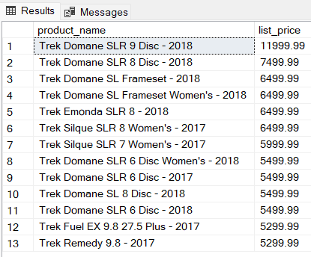

**Problem 2:** Present a list of the bikes made by a company called “Haro” in alphabetical order.

USE BikeStores

GO

SELECT product_name

FROM Production.Products INNER JOIN Production.Brands

ON Production.Products.brand_id = Production.Brands.brand_id

WHERE Production.Brands.brand_name = 'Haro'

ORDER BY product_name;

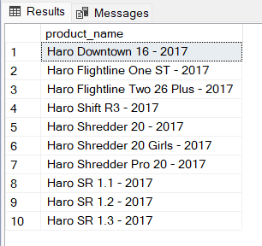

**Problem 3**: Select customer records for customers residing in the **14450** zip code.

USE BikeStores

GO

SELECT *

FROM Sales.Customers

WHERE zip_code = '14450'

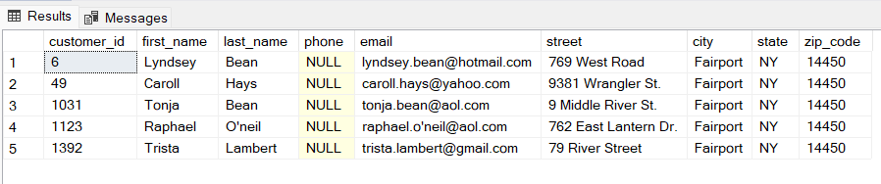

**Problem 4**: List the first and last names of staff members whose manager is Mireya Copeland.

USE BikeStores

GO

SELECT Sales.Staffs.first_name, Sales.Staffs.last_name

FROM Sales.Staffs INNER JOIN Sales.Staffs M

ON Sales.Staffs.manager_id = M.staff_id

WHERE M.first_name = 'Mireya' AND M.last_name = 'Copeland'

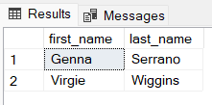

**Problem 5**: The company is now selling bikes from a company called **GT Bicycles**. Enter a new record into the database to reflect this change.

USE BikeStores

GO

INSERT INTO Production.Brands (brand_name)

VALUES ('GT Bicycles');

SELECT *

FROM Production.brands

WHERE brand_name = 'GT Bicycles'

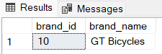

**Problem 6**: Update the amount of stock for the bike with product_id = 198 at the store with store_id = 2. The new stock amount should be 20.

USE BikeStores

GO

UPDATE Production.stocks

SET quantity = 20

WHERE product_id = 198 AND store_id= 2;

SELECT *

FROM Production.stocks

WHERE product_id = 198 AND store_id= 2;

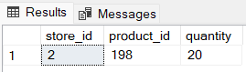

**Problem 7**: Show bike names and the total sales amounts for transactions involving bikes costing $10,000 or more. The total sales amount is the product of the bike order item list price, quantity sold, and sale discount.

USE BikeStores

GO

SELECT P.product_name, OI.list_price*quantity*discount AS SalesAmt

FROM Sales.Order_Items OI INNER JOIN Production.Products P

ON OI.product_id = P.product_id

WHERE OI.list_price >= 10000;

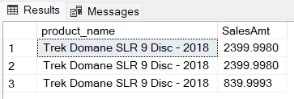

**Problem 8**: Provide a distinct list of the states in alphabetical order where the company’s customers reside.

USE BikeStores

GO

SELECT DISTINCT State

FROM Sales.Customers

ORDER BY State

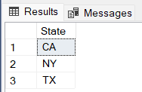

**Problem 9**: Display the full names of all staff personnel in First_Name, “ ” , Last_Name format. Use the built-in **CONCAT()** function for this query.

USE BikeStores

GO

SELECT First_Name + ' ' + Last_Name AS 'Staff Name'

FROM Sales.Staffs;

SELECT CONCAT (First_Name, ' ', Last_Name) AS 'Staff Name'

FROM Sales.Staffs;

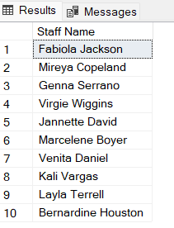

**Problem 10**: Show the bikes that have zero stock at the Texas (TX) store.

USE BikeStores

GO

SELECT product_name, state, quantity

FROM Production.Products P INNER JOIN Production.Stocks S

ON P.product_id = S.product_id

INNER JOIN Sales.Stores ST

ON S.store_id = ST.store_id

WHERE ST.state = 'TX' AND S.quantity = 0

ORDER BY product_name;

